**Snaith, Rawcliffe, Airmyn & Marshlands**

**Update for May 2019**

1. **Crime and ASB**



TFMV – Theft from motor vehicle

TOMV – Theft of motor vehicle

ASB – Anti-social behaviour

The Snaith, Rawcliffe, Airmyn and Marshlands ward experiences a relatively low level of crime compared to other areas served by Humberside Police. Although there has been a year on year increase in Criminal Damage, Theft of Motor Vehicle, Theft, Violence against the Person and ASB it is positive to see reductions in other offence categories such as Burglary. It is also worth noting that although some of the percentage increases seem high, in many cases this is because the initial number of offences recorded was so low. For example, TOMV increased by 27.3% but the number of offences only increased by three. Detailed crime and ASB data for your area can be obtained by visiting [www.police.uk](http://www.police.uk) and following the ‘Find your Neighbourhood’ link.Also details of any particular crimes or series of crimes of note e.g. serious assaults, run of Hanoi burglaries

**2. Crime issues of particular note**

**The following list shows some of the crimes that have occurred in the previous month in your area.**

* Residential Burglary - 2 burglaries committed on South Parkway, Snaith where suspects have gained entry to an insecure shed or garage. A significant amount of fishing equipment was stolen from the garage and nothing was stolen from the sheds. Please ensure that you lock and secure any outbuildings to prevent opportunist burglars from gaining entry.
* Theft from Motor Vehicle – A vehicle was parked outside keepers address on South Parkway, Snaith. Vehicle was left unlocked overnight with laptop, wallet, keys and other valuable items left in the passenger foot well. Overnight suspects have gained entry to the car and stolen all items from inside. Please ensure that you remove all valuables from your car and lock all of the doors before walking away from it.
* Possession of Controlled Drug–A vehicle was stopped on High Street, Snaith and during a search of the vehicle a number of clear plastic bags containing white powder were found. The powder was seized and the suspect was arrested an interviewed.

1. **Community Priorities**

The Neighbourhood Policing Team meet regularly with partners to ensure we have a multi-agency approach to local issues, individuals and problem solving.  These meetings are regularly attended by partners including Humberside Fire and Rescue Service, Youth and Family Support, Housing Officers, Environmental Health and the East Riding Anti-Social Behaviour Team.  We share information and resources to deal with local neighbourhood issues, in particular, those identified as causing the most harm in the community.

1. **Issue: Youths Causing Annoyance in Market Place Snaith**

Officers will be patrolling in the above area due to reports of youths congregating and causing a nuisance along with issues of littering and graffiti and general anti-social Behaviour. Anyone caught engaging in such activities will be dealt with jointly with the East Riding of Yorkshire Council.

1. **Ferry Lane Snaith**

There have been reports of youths on motorbikes on Ferry lane Snaith. Allegedly the riders are speeding, generally causing a nuisance and riding without helmets. We will be patrolling and taking action when necessary. Another group also locate the area and congregate under the bridge. There have been reports about littering and graffiti. All offenders will be dealt with and their details passed onto the council

1. **Snaith Station Car Park.**

Now the nights are darker another area of concern from the community is the station car park on George Street Snaith. We often get reports of ‘boy racers’ congregating and causing harassment, alarm and distress. We will enforce where necessary by issuing section 59 warnings. The warning will give us the power to seize the vehicle if the driver has previously been warned in the last 12 months and continue being a nuisance.

**4. Crime Reduction Advice**

**Sneak Thieves**

Now that spring is here again, we all want to relax and enjoy the warmer weather, however we still need to think about home security to prevent ourselves from becoming victims of crime.

So what do you need to consider?

* You need to ensure that your home is always secure when you go out and that you don’t leave potential entry points open and accessible, for example a downstairs window or a door. This also applies at night especially when it’s a warm muggy evening and you are thinking about leaving a downstairs window open for ventilation whilst you are asleep.
* You may be out working in the garden and out of sight of the windows or doors that you have left open. You could even be cutting the grass or hedge perhaps with a loud lawn mower/hedge cutter or be using power tools and it could be so easy in these circumstances for a sneak thief to take advantage of the situation, go inside your home and steal things, for example keys, handbags, wallets, laptops etc that are often on display or easily accessible.
* The same applies with garages. We often leave the doors wide open and go off into the garden leaving everything in them on display. How easy is it then for someone to take advantage of this situation and steal bikes, power tools or garden equipment!
* Lastly there’s your vehicles to consider: On a warm day, there might be a temptation to leave your car parked on the drive with its windows open to allow fresh air to circulate, along with items e.g. a sat nav, coat or shopping bags on clear view that you just haven’t managed to bring in doors yet!. These items can all be stolen very quickly, but the worst case scenario is that your car could be stolen too.

The kinds of thefts described are committed by opportunists who could be wandering around your neighbourhood looking to take advantage of people who leave their property insecure **so think security at all times and don’t become a victim of crime!**

1. **News and Appeals**

**Humberside Police graded as GOOD by Her Majesty’s Inspectorate**Humberside Police has been awarded an overall grading of ‘GOOD’ by HMICFRS as well as achieving a GOOD grading across every pillar of the annual inspection process.This inspection report is a comprehensive assessment of how the force is performing across a wide range of areas, including how we:

* Protect vulnerable people
* Investigate crime
* Prevent crime and tackle anti-social behaviour
* Tackle serious and organised crime

The report also assesses how efficiently the force uses its finances and resources and how sustainable these are in the future.  The inspection also assesses how the force treats its staff and how the services it provides to the public is improving.Chief Constable Lee Freeman welcomed the report, writing:

“I am really pleased with the report and the assessment from HMICFRS and whilst we know we still have much more to do, a grading of GOOD right across the board for Humberside Police is a significant milestone and a giant step in the right direction.

“When I took over as Chief in June 2017, I said that it was actions and not words that the public and my staff needed to see. I believed I had staff and officers who were professional and committed and recall saying that they were absolutely not the inhibiting factor to the force improving. I believe the turnaround we’ve achieved shows that this is the case and it is our staff who have delivered these results.

“I wish to record my thanks to all my staff for their support and hard work over the last 20 months, as it is them, along with the 492 new officers that have joined us in the last two years, who have delivered these improvements.I also want to acknowledge the key role that our partners play in keeping people safe. With the force going back to its roots with locally based policing teams across East Riding, Hull, North and North East Lincolnshire, ensuring that our relationships with all four local authorities have been excellent.

“When I became Chief, I said I wanted my officers and staff to feel proud to work at Humberside Police – and I think this is starting to happen. Reports like this help.But we also have to remember we’re not finished yet – there’s always more to do and the financial environment remains challenging.  We have savings to make, criminals are adapting to new technology and the public rightly expects us to adapt too.

“HMIC Inspectors have also recognised the work we have done to improve how we investigate crime, reforming our CID teams across the force and ensuring that the investigative training we provide our staff is of a high standard, has undoubtedly made a difference.I am also particularly pleased to see our Force Control Room being praised in this report. It is now answering more calls, more quickly, than ever before, with Humberside Police the first force in the country to offer a call back service for our non-emergency 101 service so that people don’t have to wait on the line during busy periods.

“HMICFRS have also specifically mentioned the culture of continuous improvement that we’ve been developing. I have been very clear that managers and leaders in Humberside Police are there to support and listen to their staff, as well as the public, and we have seen encouraging and sustained  improvements in levels of staff morale, wellbeing and sickness absence”.

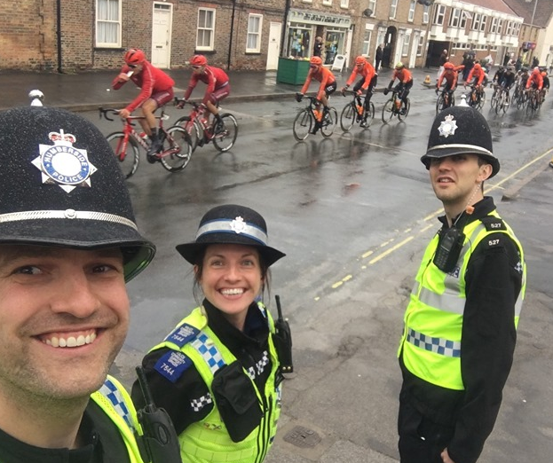**Tour De Yorkshire comes to the East Riding**

Local officers from Goole helped to police the Tour De Yorkshire when the race passed through the East Riding of Yorkshire on Thursday 2nd May and Saturday 4th May 2019.

On Thursday the race began in Doncaster and passed through Snaith, Howden, Elloughton, Beverley and Pocklington before winding its way to the finish line in Selby.

On Saturday the race started in Bridlington and our officers travelled from Goole to support the event. The race then travelled into North Yorkshire passing through Reighton, Humanby, Sleights, Whitby, Robin Hood’s Bay before finishing up in Scarborough.

**Goole Criminal Investigation Department (CID) bring Offenders to Justice**

Most members of the public often don’t see the amount of hard work that goes on behind the scenes when it comes to bringing offenders to justice. Before an individual is convicted of an offence the Crown Prosecution Service need to utilise evidence which is gathered primarily by the police to prove beyond all reasonable doubt that someone is guilty. For the police, this often means tireless hours of taking witness statements, looking through CCTV, interviewing suspects and preparing court files. Below is just a summary of the court results from Wednesday 10th and Thursday 11th April 2019:

* Kylie NEWMAN, 30 of North Street in GOOLE, pleaded guilty to one count of theft, two counts of fraud by false representation and one count of theft. She was committed to Hull Crown Court for sentencing on 9th May 2019 following pre-sentence reports.
* Thomas NICHOLSON, 31 of Stafford Street in CASTLEFORD, pleaded guilty to assault police in GOOLE on 8th August 2018, and not guilty to driving a vehicle on the M62 at GOOLE whilst unfit to drive through drugs. He was found guilty of the second offence, and will be sentenced at Beverley Magistrates Court on 8th May 2019 following pre-sentence reports.
* Simon BEDFORD, 37 from HOLME UPON SPALDING MOOR, pleaded guilty to driving whilst disqualified, driving without due care and attention, and driving without insurance. He received a 12 week prison sentence, suspended for 12 months, and must attend 19 days of rehabilitation.
* Matthew DANIELS, 33 from Percy Street in OLD GOOLE, admitted breaching a community order issued by York Magistrates in 2018. He was ordered to carry out 210 hours of unpaid work.
* Jamie HOLDEN, 26 from Elsie Street in GOOLE, pleaded guilty to driving whilst over the prescribed alcohol limit. He was disqualified from driving for 12 months.
* Bryan KNIGHT, 57 from Third Avenue in GOOLE, pleaded guilty to breaching an animal welfare disqualification order. He received a 6 month Conditional Discharge.
* Luke WOODALL, 22 from Birch Grove in GOOLE, pleaded guilty to driving whilst over the prescribed alcohol limit and driving without insurance. He was disqualified from driving for 12 months.
* Amanda DOUGLAS, 45 of Moorland Road in OLD GOOLE, pleaded guilty to assault by beating. Sentencing deferred until 8th May 2019 for pre-sentence reports.

1. **Meet your officers**

**Snaith, Airmyn, Rawcliffe & Marshlands**

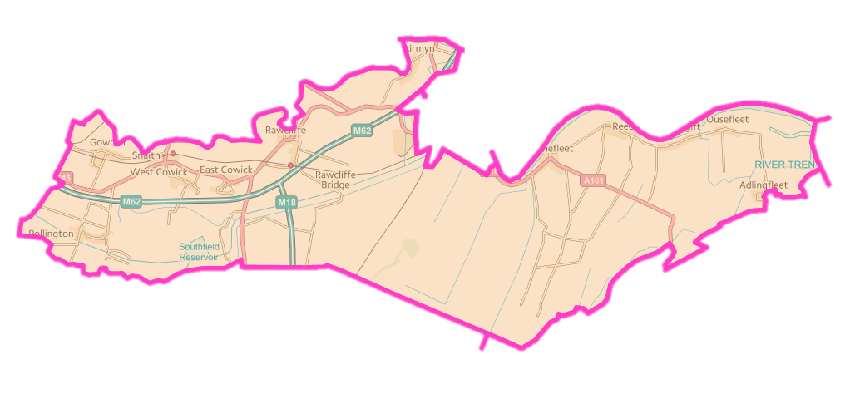

PCSO Sam Chandler will be at the **Snaith Town Council Offices in Market Place** on **Wednesday 22nd May 2019** between **18:00 and 19:30 hours.**

Community alerts is a new, free messaging system operated by Humberside Police, to help keep you updated about what is happening in your local area. Choose how you receive messages by phone or email, how often you want to hear from us and about the issues that matter to you. Sign up for free at: www.mycommunityalert.co.ukto start receiving real time updates now.